SACRED HEART PARISH

Sacred Heart Parish Founded 1814, The First Catholic Parish in the STate of New Jersey

Sacred Heart Church, 343 South broad Street, Trenton, New Jersey 08608

Holy Cross Church, 233 Adeline Street, Trenton, New Jersey 08611

ALL ARE WELCOME

Whatever your present status in the Catholic Church, whatever your current family or marital situation,

Whatever your past or present religious affiliation, whatever your personal history, age, background, or

race, whatever your own self-image or esteem, you are invited, welcomed, accepted, loved and

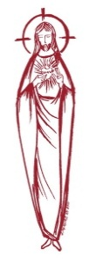
respected at the Parish of the Sacred Heart.

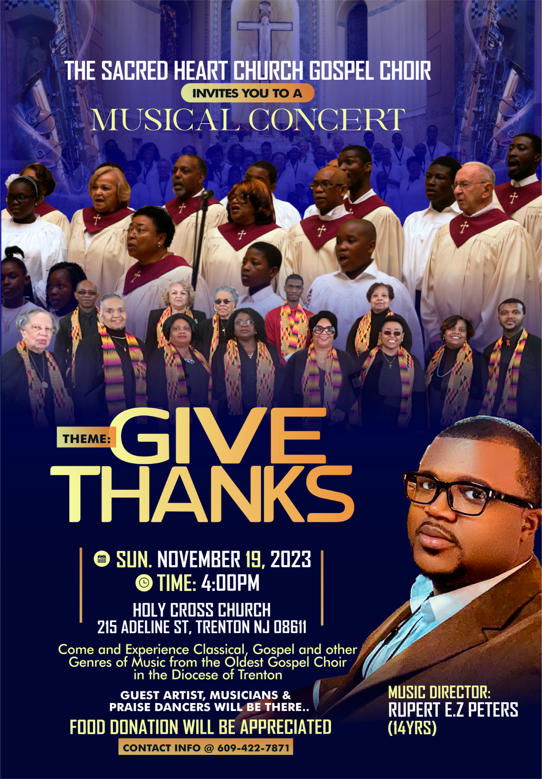

TWENTY-NINTH SUNDAY IN ORDINARY TIME
October 22, 2023

MASS INTENTIONS
Saturday, October 21
4:00 pm ~ Ronald A. Brodowski
5:15 pm SHC ~ Sheils Family
Sunday, October 22
9:00 SHC ~ MaryAnn Hoch and Ridorfino Family
10:00 HCC ~ For the People of the Parish
11:15 SHC ~ Patricia and Karen Romanowsky
12:00 HCC Polish ~
Monday, October 23
8:00 am HCC ~ Karl Rein
12:10pm SHC ~ Larry R Jones, Sr.
Tuesday, October24
12:10 pm SHC ~ Lena Apoldite
Wednesday, October 25
12:10 pm SHC ~ Ann Liberatori
Thursday, October 26
8:00 am HCC ~ Richard Tatka
Friday, October 27
8:00 am HCC ~ Bruno Torring
12:10pm SHC ~ Kenneth Erath
Saturday, October 28
4:00 pm ~ H Weiss and Margaret Bliznawcz
5:15 pm SHC ~ Johanna Schino
Sunday, October 29
9:00 SHC ~ Steve Yesensky
10:00 HCC ~
11:15 SHC ~ Intentions of the People of the Parish
12:00 HCC Polish ~ Stanislaw Tylutki

OUR SICK LIST
Robin Haynes, Ann Szostak, Lorraine Wargo, Robert Paci, Mrs. Loatman, David Carver, Gertrude Siber, Jennifer Lyons, Grace Profy, Steve Jurczynski, Cornell Hess, Ruby Covington, Judith Santigo, Ching Kukis, Dan Breese Jr, Brenna Kennedy-Moore, Dawn Chia, Mark Friedman, Alexander A. Ladnyk, Kelly Nitti, Lauren Clayton, Joseph Edralin, Margie Tiongson, Kevin, Vincent Cooper, Jr., Gail Ladnyk, Leo Genovesi, Sloane Donnelly, Richard Buckley, Tony Ragolia, Barbara Burrows, Charles Burrows, Dorothy Amoroso, Maryann Sullivan, Regina Friedman, Stanley Winowicz, Greg Schafer, Jack Hardiman, Amy Birk, Julia Grazioli, Matt Tydryszewski.
OUR DECEASED

Bob Watkin, Stanley Tylutki, Henry Jakubicki, and our friends at South Village, Riverside Nursing and Rehabilitation Center, Mill House and Waters Edge.

MINISTRY SCHEDULE
(subject to change)
Saturday, October 21
4:00pm HCC ~ Fr Charles L. R. Micharski Em. M. Herpel
5:15pm SHC ~ Fr Charles L. C Hernandez Em. J. & K. DiBenedetto
Sunday, October 22
9:00 SHC Msgr. Dennis L. J. McDonough Em. J. DeSantis & J. Ellie
10:00 HCC ~ Fr. Charles L. M. Days Em. W. Hilton
11:15 SHC ~ Msgr Dennis L. J. Blizard Em. B. Allaire & L. Boyle
12:00 HCC Polish ~ Fr Marian, Ewa, Danuta

Saturday, October 28
4:00pm HCC ~ Fr Charles L. V. Zielinski Em. A. Lennon
5:15pm SHC ~ Msgr. Dennis L. L. Bellina Em. S & K Farruggio
Sunday, October 29
9:00 SHC ~ Msgr. Dennis L. A. Urbaniak Em. H.&M. Figueroa
10:00 HCC ~ Fr. Charles L. F. Kollie Em. G. Mowenn
11:15 SHC ~ Msgr Dennis L. D Allen Em. J. Bautz & J. Diaz
12:00 HCC Polish ~ Fr Marian, Anna, Mieciu

WEEKLY COLLECTION
Last weekend’s collection amounted to $8,700.00. This includes the donations received in Church and the mail ins. Thank you for your continued support of our parish.

2023 ANNUAL CATHOLIC APPEAL UPDATE
Goal: $33,000.00 :
Pledged: $45,301.00 (137% of Goal)

READINGS FOR THE WEEK
Twenty-ninth Week in Ordinary Time
Sunday Is 45:1, 4-6; 1 Thes 1:1-5b; Mt 22:15-21
Monday Rom 4:20-25; Lk 12:13-21
Tuesday Rom 5:12, 15b, 17-19, 20b-21; Lk 12:35-38
Wednesday Rom 6:12-18; Lk 12:39-48
Thursday Rom 6:19-23; Lk 12:49-53
Friday Rom 7:18-25a; Lk 12:54-59
Saturday Eph 2:19-22; Lk 6:12-16

PROMISE TO PROTECT
The Diocese of Trenton is committed to the norms of the U.S. Bishop’s Charter for the Protection of Children and Young People in regard to the reporting and investigation of sexual abuse allegations involving minors. If you have been sexually abused as a minor by anyone representing the Catholic Church, you can report that abuse through the diocesan Hotline: 1-888-296-2965 or abuseline@dioceseoftrenton.org. Allegations are reported to the appropriate law enforcement agencies.

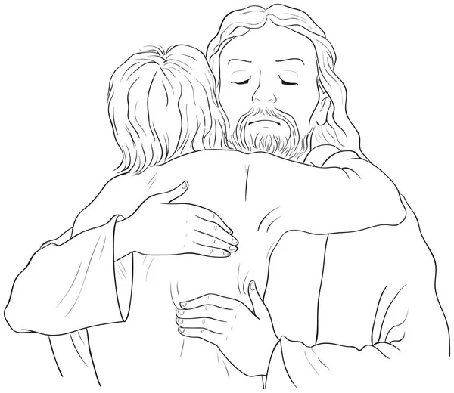

Grief Focused Jesus ACTion
Death, Loss and Grief: Exploring How to Live in the Present, Heal from the Past and Embrace the Future with Courage.
Presenter:
Rev. Fr. Charles Muorah PhD., STL, LMFT
One Day Workshop! Saturday, November 4, 2023
Time: 9:3Oam – 12:00 noon
Venue: One Centre Street
(Adjacent to Sacred Heart Church), Trenton
“Grief is a natural response to loss. It’s the emotional suffering you feel when something or someone you love is taken away. The more significant the loss, the more intense the grief will be” (Smith & Segal, 2016).
“The souls of the just are in the hand of God” (Wisdom 3:1)
Each year, on November 2nd the Catholic Church commemorates the dead and the month of November is dedicated to honoring and praying for the dead. The feeling of loss is intense. Healthy grief work is a unique way to honor the dead. Come join us to comfort one another.
“Blessed are those who mourn, for they will be comforted” (Matthew 5:4).
Objectives:
• To discuss natural reactions to grief, themes and compounding issues emerging from grief, relational repairs and how spirituality can help.
• To develop more psychological flexibility (upholding my values and responding in a healthy way to life challenges) in exploring death, loss and private experiences
• To find new ways of being in relationship with the deceased
• To live in the present, heal from the past/loss and embrace the future with courage.

To Register for the workshop please call the parish office at 609-393-2801.

FIRST BLACK CATHOLIC CHURCH,
TRENTON DIOCESE

“The Church of Our lady of the Divine Shepherd Church was founded as a Roman Catholic parish, the first in the Diocese of Trenton specifically for African Americans, on this site in 1941 in response to a petition from hundreds of black Catholics to Bishop William Griffin. He ordered the purchase of the former home of the State Lodge of the Negro Masons of New Jersey, erected here in 1928, for the new parish. The bishop celebrated the first Mass on June 14, 1941.
The parish opened a school here in September 1943, originally staffed by Franciscan nuns from Austria and later by a black order, the Oblate Sisters of Providence. Priests of the Society of the Divine Word served the parish faithfully over the years. Hundreds of African American Catholics who served God and the community worshipped joyfully in this church. They were baptized, educated, married, spiritually uplifted and memorialized here. The parish merged with the Church of the Blessed Sacrament in 2005 and relocated to its site at 716 Belevue Avenue on Christmas eve 2008.”
These words are found on the newly installed plaque on the side of the One Centre Street Building. The plaque was originally erected on the site of the Church of the Divine Shepherd, located at 34 Pennington Avenue, Trenton, near the Washington Monument. Due to a variety of reason, the Church was merged with Blessed Sacrament Parish in 2005 and in 2008, the Church of the Divine Shepherd was closed. The congregation was then merged with the congregation on Belevue Avenue, Trenton and became known as the Parish of Blessed Sacrament – Our Lady of Divine Shepherd. This plaque was moved from the Divine Shepherd site and was relocated to the grounds of Blessed Sacrament Church. On July 1, 2018, this parish was merged with Sacred Heart Parish and it is here that they have found a welcoming community. We give honor to the people and history of The Parish of Our Lady of the Divine Shepherd by erecting this plaque on our historical grounds. There is a tremendous legacy that belongs to the people of the original First Black Catholic Church in our Trenton Diocese and we are proud to have their heritage mingled with ours.
YOUR CONTACT INFORMATION
We have found a new program for our parish that will improve our communication to inform you of events in the parish. We are asking that you write on the back of your church donation envelope your cell phone number where you can receive text messages or email your information to John at secretary@trentonsacredheart.org

PRAYER FOR THE SYNOD
We stand before You, Holy Spirit,
as we gather together in Your name.
With You alone to guide us,
make Yourself at home in our hearts.
Teach us the way we must go and how we are to pursue it. We are weak and sinful.
do not let us promote disorder.
Do not let ignorance
lead us down the wrong path
nor partiality influence our actions.
Let us find in You our unity so that we
may journey together to eternal life
and not stray from the way of truth
and what is right.
All this we ask of You, who are at work
in every place and time, in the
communion of the Father and the Son,
forever and ever. Amen.

OCTOBER MASS COUNT
This weekend October 21st & 22nd, the Office of Planning for the Diocese of Trenton has asked that every person be counted at each weekend Liturgy. Although this “count” will not affect anyone directly, we wanted you to know that this process is taking place. Hopefully we can count on your being with us.

RITE OF WELCOME
Our candidates for the Easter Sacraments have gone through the initial inquiry period in the OC.I.A. process which began in September. This Sunday at the 9:00 am Mass, we as a community of faith, will welcome them along with their sponsors, as they participate in the Rite of Welcome.

THIS WEEKEND: MISSION SUNDAY
This weekend, October 21st & 22nd has been designated as Mission Sunday throughout the world. Your generous contributions will be shared through our Propagation of the Faith Office to world mission communities. keep all missionaries in your prayers as they strive to evangelize all they serve. In 1926 Pope Pius XI instituted Mission Sunday for the whole Church with the first worldwide Mission Sunday collection taking place in October 1927. That day is celebrated in all the local Churches as the feast of catholicity and universal solidarity so Christians the world over will recognize their common responsibility with regard to the evangelization of the world. Therefore we will have a second collection this weekend for the Missions.

MASS BOOK FOR 2024
Our Mass Intention Book for 2024 is now open for your requests. Please note that since we have many requests for the weekend Mass schedule, we will now be accepting three intentions per Mass only on the weekends. The stipend remains at $10.00 per intention. On weekdays and Holy Days we will schedule only one intention per Mass. Contact the parish office to schedule your Mass intentions.

FINANCIAL REPORT FOR 2022-2023
The annual report of the financial status for the fiscal year, 2022 - 2023 can be found on the printed copy of this bulletin only. If you can add a dollar or two to your weekly donation it will certainly be appreciated. If you have any questions concerning the financial report, please call the parish office and ask for Msgr. Dennis.

SOLEMN ST. JUDE NOVENA
St. Michael Church is celebrating the Solemn Novena of St. Jude from October 20th to the 28th. For more information, and for the schedule, please visit https://www.churchofsaintann.net/st-michaels-church.

ALL SOULS REMEMBRANCE
Please remember to send in your All Souls Mass Remembrance. These envelopes, with the names of your deceased loved ones, will be placed on the Altars during the month of November.

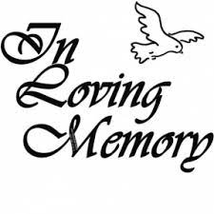
REMEMBER OUR DECEASED
Once again, we will be honoring all those who were buried from our Sacred Heart Parish and any parishioner who experienced a death in their family since mid-October 2022. If you would like to participate in this ceremony we ask that you bring a framed (no larger than a 5 in. x 7 in.) picture of your deceased loved one to Mass on the weekend of October 28-29. Please attach your name and phone number to the back of the picture (all pictures will be returned). At every Mass that weekend, all the names will be read, so whatever Mass you attend you will be asked to bring the picture up to the Table of Remembrance in the sanctuary at Sacred Heart Church and to the side Altar of Saint Francis or Our Lady of Czestochowa in Holy Cross Church. The names will be called at the Universal Prayer. Pictures will remain in the Church until the end of November. Please consider participating in this ceremony to honor our beloved deceased. Thank you.

ONLY FOR A SHORT WHILE

Oh, only for so short a while you have loaned us to each other, because we take form in your act of drawing us, and we take life in your painting us, and we breathe in your singing us.
But only for so short a while have you loaned us to each other. Because even a drawing cut in obsidian fades, and the green feathers, the crown feathers, of the Quetzal bird lose their color, and even the sounds of the waterfall
die out in the dry season. So, we too, because only for a short while have you loaned us to each other.
- Aztec Indian Prayer

MISSION SUNDAY LETTER
Dear Friends in our Mission Family,
Peace!
World Mission Sunday will be celebrated this year on the weekend of Oct. 21 and 22. Our Diocesan celebration will take place in St. Gregory the Great Church, Hamilton Square, on Oct. 22 at the 12 p.m. Mass.
Marleyna Kaufmann, a student from the Religious Education Program of St. Veronica’s Parish, was one of 24 young people from throughout the country to have her artwork selected as a winner in the National Christmas Art Contest of the Missionary Childhood Association. It will be an honor for me to present the award to Marleyna. We will also recognize Olivia Maleson, a fourth grade student in St. Gregory the Great Academy, for her generosity and innovative work to raise money for the Missions, along with her classmates.
As Bishop O’Connell has shared, “Hearts on fire, feet on the move” and World Mission Sunday gives us this important opportunity to reach out to the Mission Church, to speak about our faith and about missionaries who proclaim the Gospel as they serve the poor. We each can participate in this worldwide moment for prayerful and financial support for the Pope’s missions. I humbly and sincerely ask for your own joyful participation in the Church’s worldwide moment for prayerful and financial support for the Church’s Missions, particularly our collection for the Society for the Propagation of the Faith.
Through this collection, you provide for more than 1,100 mission dioceses in territories covering more than half the globe. Your prayers and sacrifices will support priests, religious, and lay pastoral leaders who are proclaiming the Gospel, building the Church, and serving the poor and most vulnerable. Their work and witness to Christ brings both practical help and God’s love, hope and peace.
May your help and love for the Church’s Mission, which is a passion for Jesus and a passion for His people, grow ever stronger. I thank you as well for all you do for the missionary work of the Church each October.

United with you in prayer and faith,

Rev. Peter James Alindogan,
Diocesan Director of Missions

